

Asia Pacific College

School of Computing and Information Technologies

Magallanes, Makati City

IDENTIFYING FAKE NEWS

Project Documentation Submitted
to the Faculty of School of
Computing and Information Technologies
Of

Asia Pacific College

By

Marc Anthony Nares

Aleo De Leon

Wyatt Holgado

BSCS-SS / SS152

To

Dr. Manuel Calimlim
 |  | Contents
Contents |  | 2
Abstract |  | 3
I. | Introduction | 4
Project Context |  | 4
Purpose and Description |  | 4
Objectives |  | 5
Scope and Limitations |  | 5
II. Project Organization |  | 7
III. Managerial Process Plan |  | 8
IV. Quality Management Plan
V. Human Resource Management Plan
VI. Risk Management Plan
VII. Conclusions and Recommendations |  | 11
VI. | References | 11

Abstract

This document circles around fake news on the internet. In this research, the researchers will

create a system that identifies if a link posted on the internet leads to an article that is fake or not. It

will be implemented through a web extension that will only run on social media sites. Considering

that there are various ways in identifying fake news, this document will be providing solutions on

how to identify fake news.

KEYWORDS: Fake news, classification

Page | 3

I. Project Overview

- Introduction

Project Context

Fake news is a deliberate misinformation or hoax that spreads via traditional print, broadcast news media or online social media (Novotny, 2017). It misleads people and make the world less informed. It harms the community and the industry in an alarming level (Stecula, n.d.).

Mocha Uson shared a post of a Duterte supporter which claimed that a young girl was murdered due to the drug problem in the Philippines. She was reportedly outraged as to why the Commission on Human Rights didn’t focus on the incident. However, the link showed a photo of a nine -year-old Brazilian girl who was raped and murdered in 2014. BBC called her on it and she later took down the post (ARIAS, 2017). With the way on how fake news is spreading, it would be ideal to have application that help identify fake news online.

Purpose and Description

Fake news is a news article that gives false information intentionally and could mislead readers. The purpose of this project is to give awareness to online users from being tricked by fake news. The proponents will use an algorithm that can identify fake news in the internet. It will be implemented through an extension that will work only on Google Chrome.

Page | 4

Objectives

The objectives of this study are:

- To create a system that determine whether a link leads to a fake news article or not.

- To create a web extension that can identify whether a link clicked by a user leads to a fake news article or not.

Scope and Limitations

The study is about identifying fake news. The researchers will use web programming languages to create a web extension for identifying fake news. The gathered datasets will come from two online websites (kaggle.com,Opensources). The web extension will only work on the latest and upcoming versions Google Chrome and it will not work on any other browsers.

This study is only limited in identifying fake news on social media sites and it will not identify fake news on other sites.

Page | 5

1.5 Assumptions, Dependencies, and Constraints
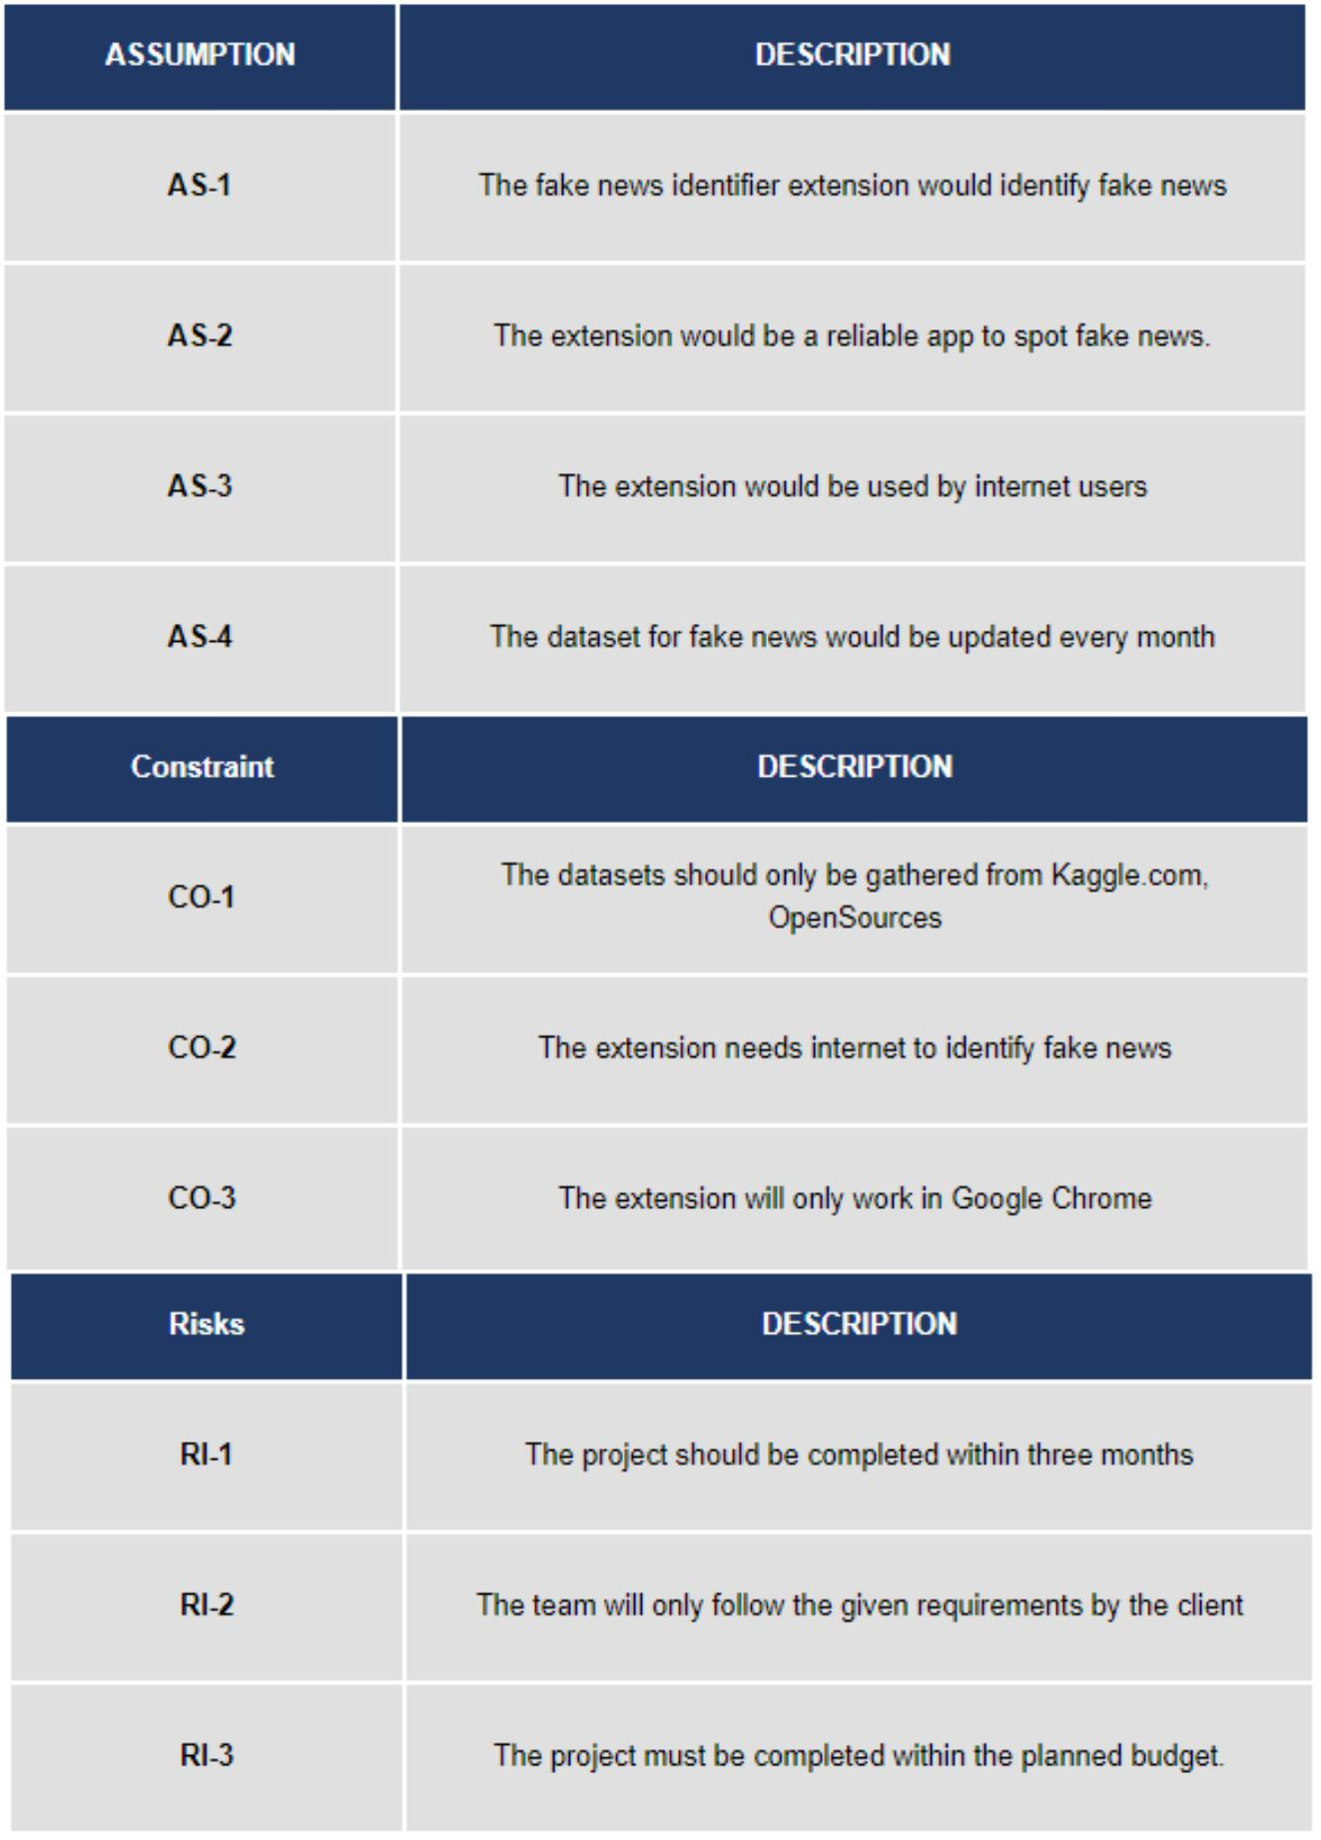
1.6 Project Deliverables

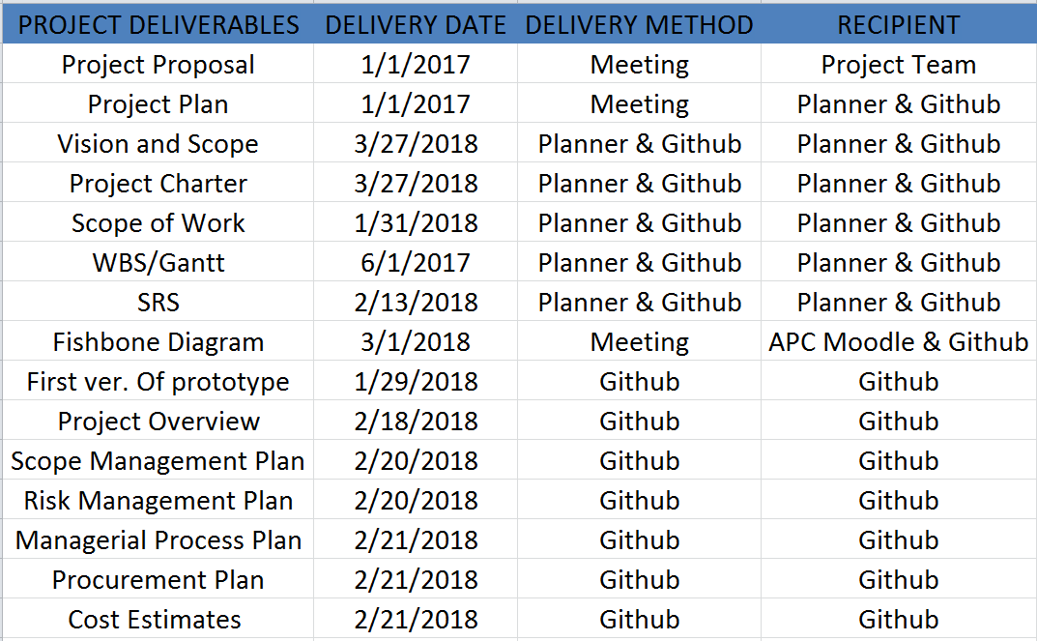

II. Project Organization

1.1 Internal Structures
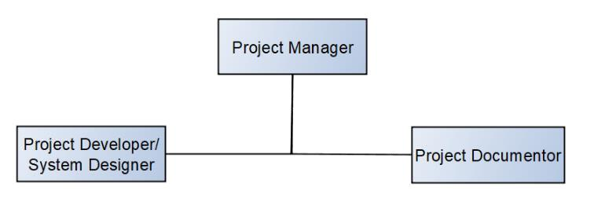
III. Managerial Process Plan

1.1 Fish-bone Diagram
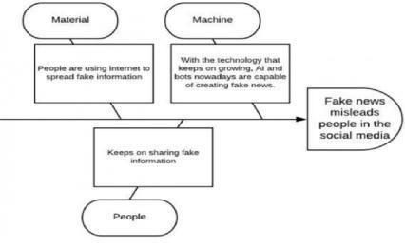

1.2 Five Whys
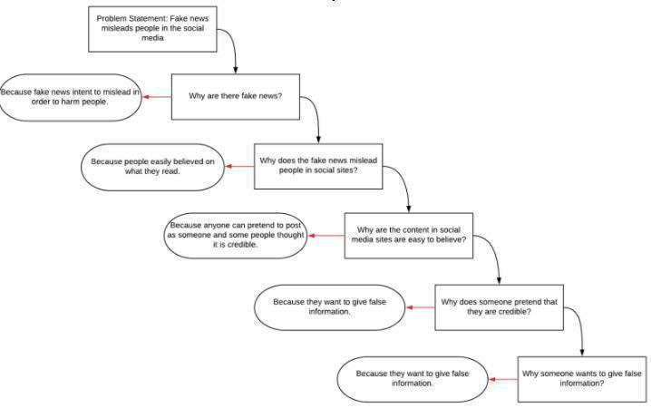

Page | 8

1.3 Estimates
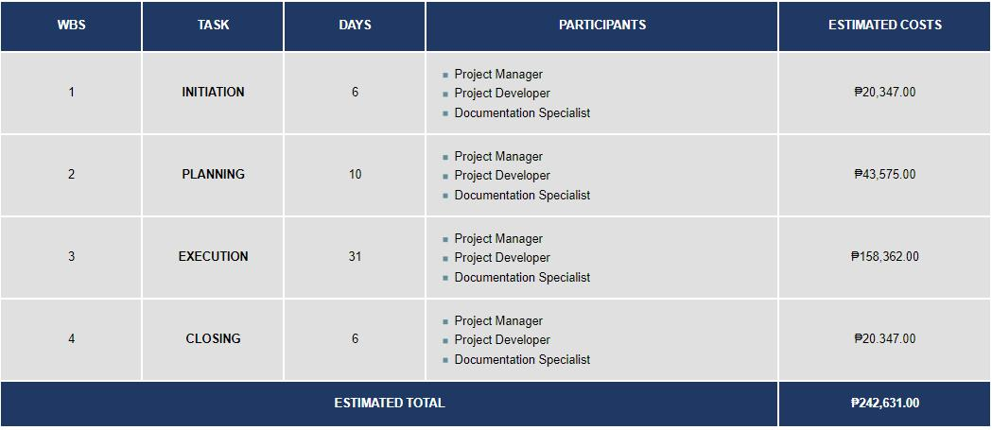

1.4 Gantt Chart
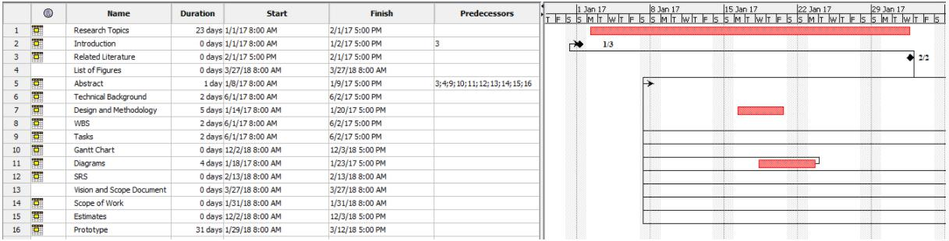

1.5 Work Breakdown Structure
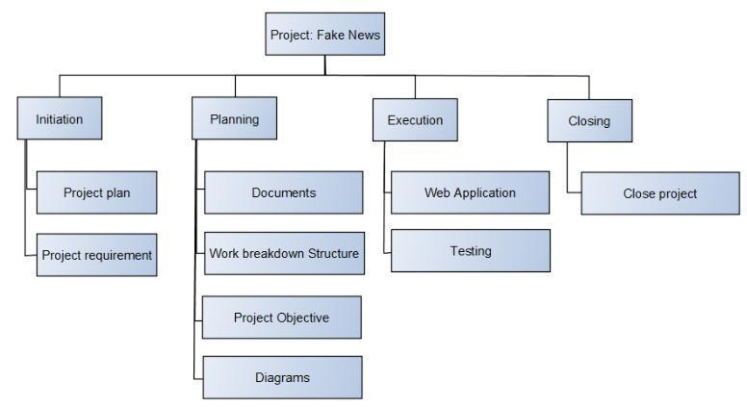
1.6 Costing
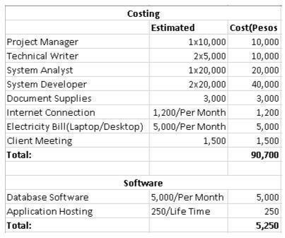

1.7 Communications Plan

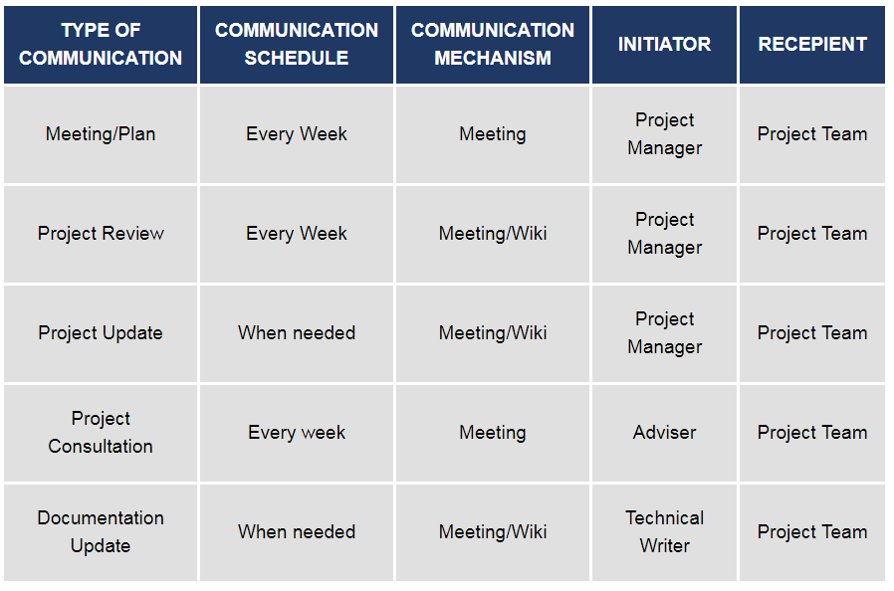

IV. QUALITY MANAGEMENT PLAN

The quality management plan of Identifying Fake News will focus on the process and procedures for ensuring quality of the Identifying Fake News in terms of monitoring the project during the testing process.

The purpose of this plan is to:

- Ensure high quality output of the project.

  - -To assure the quality of the system there will be numerous types of testing that will be done by software testers.

- Define the quality objectives of the project
V. HUMAN RESOURCE MANAGEMENT PLAN

A. Introduction

The Human Resource Management Plan allows the researchers, project manager and members to classify and understand the roles and responsibilities of each project team member. The role of this plan is to recognize the roles and responsibilities of the different positions and skills needed for the project. The purpose of the Human Resources Management Plan is to ensure that the project has the correct human resources with the right set of skills to finish the project.

This will guarantee the value and effectiveness of assigning tasks or activities to each team member in order to complete the project requirements and deliverables.

B. Roles and Tasks
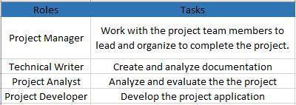

VI. Risk Management Plan

A. Risk Management Strategy

1. Risk Identification Process

The team must identify, define the risks. To evaluate each risks that will carry out the project implementation to success. By identifying risks, the team will determine how the risks will affect the project plan, implementation and execution. For every risk, the team will prepare a solution that will decrease the chance of triggering it.

2. Risk Evaluation and Prioritization

The team will estimate how the risks will delay the project management plan to execution plan. The team will prioritize on preparing the web extension application for more risks like bugs, security, compatibility and interface.

3. Risk Mitigation Options

The team will develop a risk mitigation plan and quality plan will focus on the process and procedures for ensuring quality and risks of Identifying Fake News project in terms of monitoring during the testing process.

4. Risk Plan Maintenance

To assure the methods for maintaining or updating the risk plan of the project there will be numerous types of testing that will be done by software testers to ensure the high quality of the output of the project.

B. Risk Analysis Summary
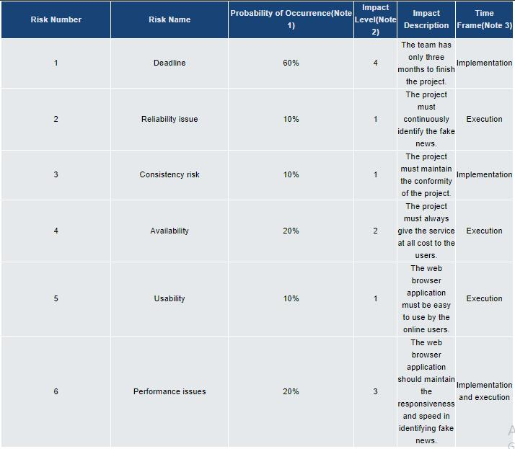

Page | 12

C. Risk Response Summary
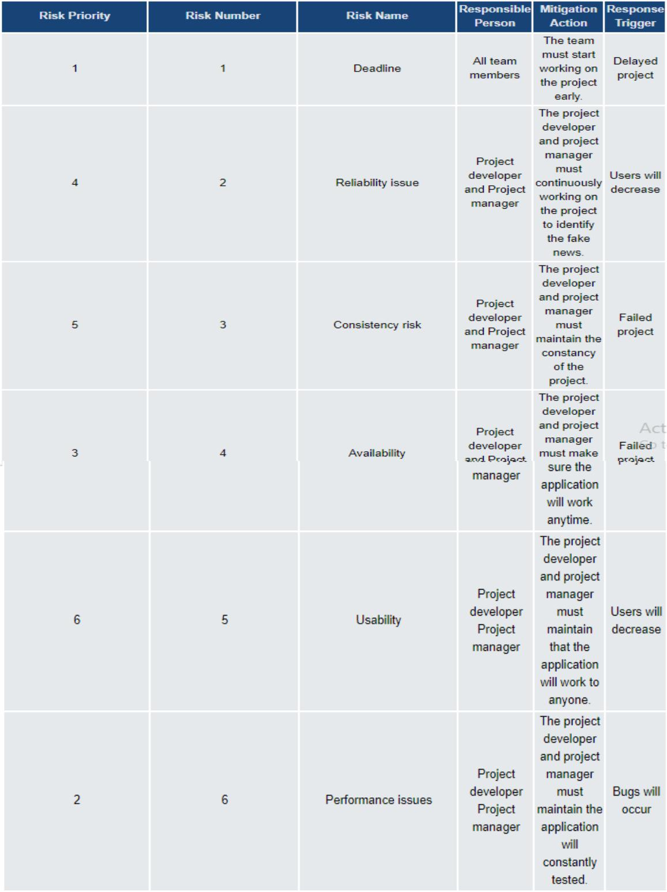
VII. Conclusions and Recommendations

Fake news can be lessened or better yet eliminated, since people keep falling prey for such posts; it needs to be stopped. This paper is meant to do just that; the program we are proposing is meant to detect if the news posted in your social media websites, which would literally get marked as a fake if it is one. To identify fake news, one must check URL. This program will be a plugin for the users’ internet browsers, but will only work for social media sites, and will not detect if posted news are fake from other websites. If this program could be implemented, there will definitely be a big change in how news would be spread, since users will no longer fall for faulty news articles and posts. This extension will also help users from falling to a phishing sites. For the basis for costing and several details, we gathered the information from the reliable sources about the average costing in the Philippines and we estimated it. For example, the researchers used the average costing for project manager, web developer, and document specialist and divided it for 12 months and divided it again by 22 working days then multiplied it by the number of days.

To help increase the accuracy of the extension, the researchers recommend adding more features for classifying data and to work not only in chrome but also on other browsers.

VIII. Screenshot
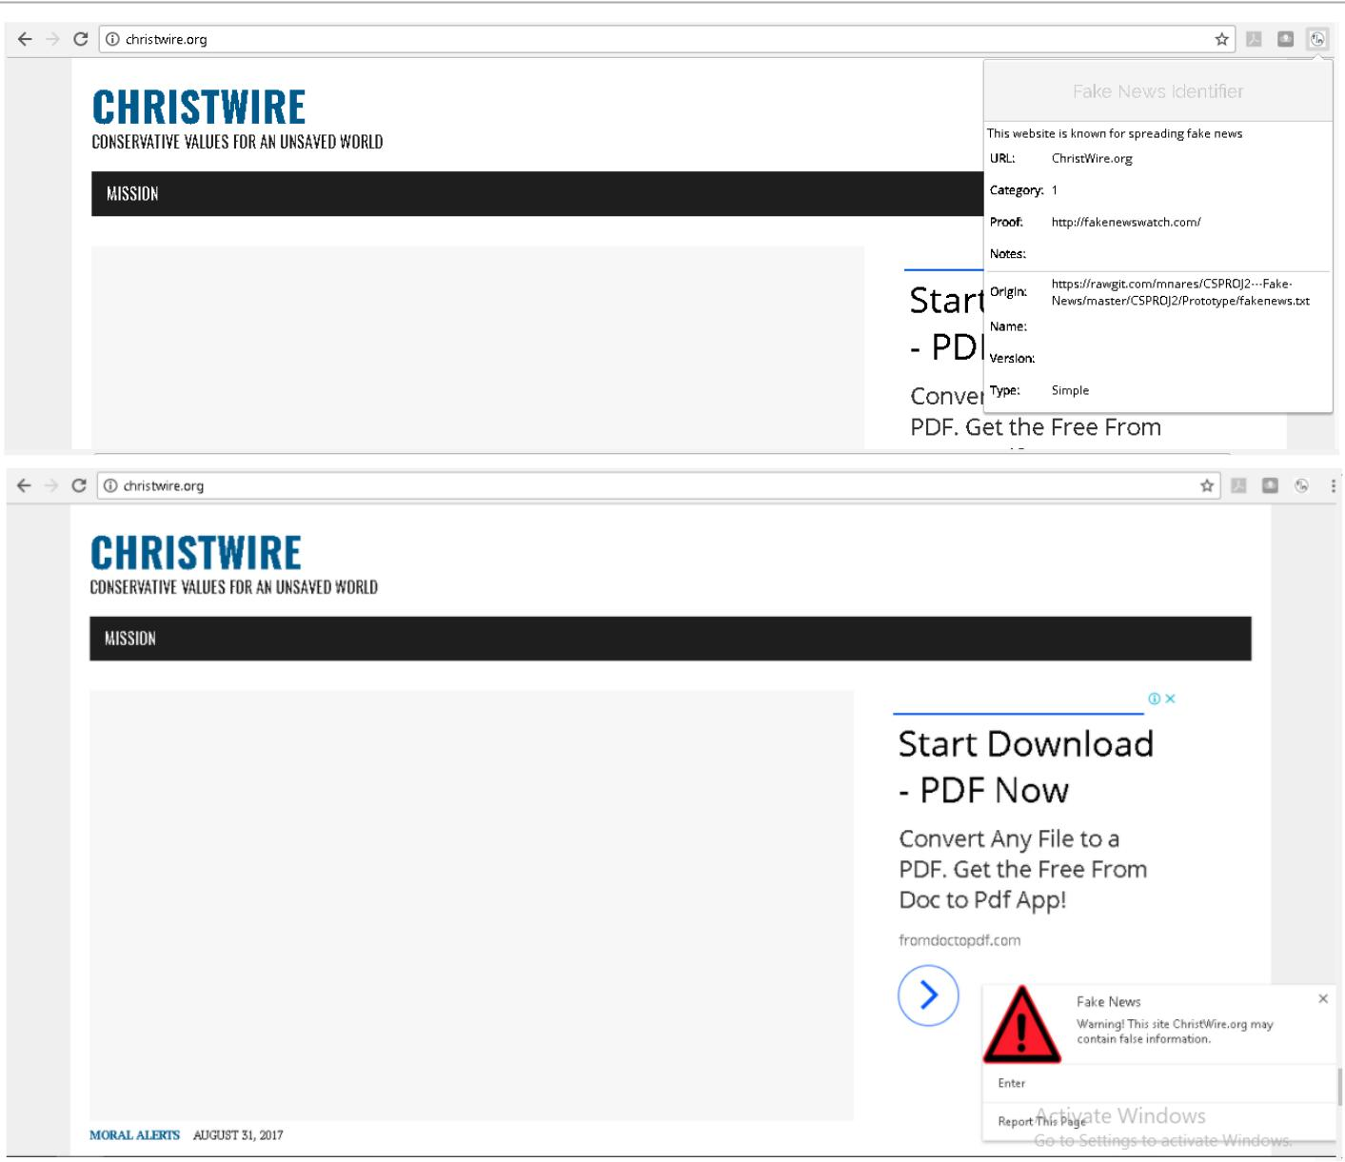

VI. References

ARIAS, J. (2017, October 4). Inquirer.net. Retrieved from Preen:
http://preen.inquirer.net/58185/a - list-of-mocha-usons-fake-news-posts

Baljit Singh Saini, A. B. (n.d.). A Review of Bot Protection using CAPTCHA for Web Security.
IOSR Journal of Computer Engineering.

Bisson, D. (2015, September 13). The State of Security. Retrieved from tripwire: https://www.tripwire.com/state-of-security/security-data-protection/cyber-security/most-suspicious-tlds-revealed-by-blue-coat-systems/

Dezyre. (2017, June 20). Retrieved from dezyre:
https://www.dezyre.com/article/top-10-machine-learning-algorithms/202
Eugene Kiely, L. R. (2016, November 18). FactCheck .org. Retrieved
from

http://www.factcheck.org/2016/11/how -to-s pot-fake-news/ Google. (n.d.). Retrieved from Google reCAPTCHA: https://www.google.com/recaptcha/intro/android.htm l Greg. (2017, January 24). yhat. Retrieved from yhat:
http://blog.yhat.com/posts/why - support-vector-machine.html

Howell, J. (n.d.). Research Gate. Retrieved from Research Gate: https://www.researchgate.net/scientific

- contributions/10074391_Jon_Howell IBM. (n.d.). Retrieved from IBM knowledge center:
https://www.ibm.com/support/knowledgecenter/en/SS3RA7_15.

0.0/com.ibm.spss.modeler.help/s vm_howwork.htm Machine Learning 101. (n.d.). Retrieved from Medium:

https://medium.com/machine-learning-101/chapter-2-svm -support - vector-machine-theory-f0812effc72

Mark Verstraete1, D. E. (n.d.). Identifying and Countering fak e news. Retrieved from https://webcache.googleusercontent.com/search?q=cache:JZsN3vbXxE4J:https://law.a rizona.edu/sites/default/files/asset/document/fakenewsfinal.pdf+&cd=2&hl=en&ct =clnk&gl=ph

McIntire, G. (n.d.). Machine Learning Finds “Fak e News” with 88% Accuracy. Retrieved from KDnugget: http://www.kdnuggets.com/2017/04/machine -learning-fake-news-accuracy.html

Media Insight Project. (2016, March 17). American Express Institute. Retrieved from https://www.americanpressinstitute.org/publications/reports/survey -research/trust-news/
Novotny, E. (2017, August 1). PennState. Retrieved from libraries.

Opensources. (n.d.). Retrieved from OpenSources: http://www.opensources.co/
Palmisano, S. (2016, December 29). EagleNews. Retrieved from eaglenews:
htp://eaglenews.org/opinion/fake-news-leads-to-real-problems/

Patag, K. J. (2017, October 4). Phil Star Global. Retrieved from Phil Star Global: http://www.philstar.com/headlines/2017/10/04/1745491/no -govt-agency-monitoring-fake-news-social-media-nbi-exec-says

Rappler. (2017, April 10). Retrieved from http://www.rappler.com/technology/social - media/166326-how-to-spot-fake-news-facebook

Sathyanarayana, S. V. (n.d.). Data classification using Support vector. Data classification using Support vector.
stack exchange. (n.d.). Retrieved from crossvalidated:

https://stats.stackexchange.com/questions/23391/how-does-a-support-vector-machine-s vm -work

Stack exchange. (n.d.). Retrieved from ComputerScience: https://cs.stackexchange.com/questions/10304/which-classifier-is-more-accurate-for-a-s vm-classification
Stecula, D. (n.d.). The conversation. Retrieved from theconversation: http://theconversation.com/the -
real -

consequences-
of-fake-news-81179

Zimdars, M. (n.d.). Opensources. Retrieved from Opensources.co: http://www.opensources.co/ Giovanni, C.(Feb. 2017)

educated.

Retrieved from: https://www.japantimes.co.jp/news/2017/02/07/business/facebook-google-testing-apps-spot-fake-news-experts-say-key-educated/#.WlM6JlWWZpg and http://technology.inquirer.net/58483/fighting-fake-news-isnt-just-facebook-google

Fillipo, M. (Dec. 2016) Indiana University researchers launch tool to understand spread of fake news. Retrieved from: http://archive.news.indiana.edu/releases/iu/2016/12/iu-hoaxy.shtml
https://www.projectsmart.co.uk/the-role-of-the-project-manager.php
https://www.greatsampleresume.com/job-responsibilities/project-developer-responsibilities/
https://www.truity.com/career-profile/technical-writer
https://www.greatsampleresume.com/job-responsibilities/project-analyst-responsibilities/
https://www.payscale.com/research/PH/Job=Web_Developer/Salary
https://www.payscale.com/research/PH/Job=Project_Manager%2C_Information_Technology_(IT)/Salary
https://www.payscale.com/research/PH/Job=Documentation_Specialist/Salary

